Settings to disable User Prompts for TestNav

- Trusted Sites – stops the Browser from prompting to Allow Java to run
- Pop-up Blocker – Allows TestNav to go full screen without prompting the user
- Java Certificates – stops the Application Run message from prompting the user (if the user clicks cancel or does not click run in time, a “Java has not been installed…” error will pop-up from Pearson as shown below)
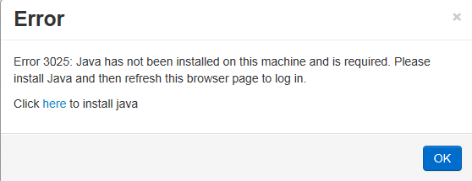

Trusted Sites

- You need to add the following sites to the Trusted Sites to allow Java to run without requiring user intervention:

http://parcc.testnav.com
http://parcctrng.testnav.com

- Screenshot of sites added to Trusted Sites is shown below:
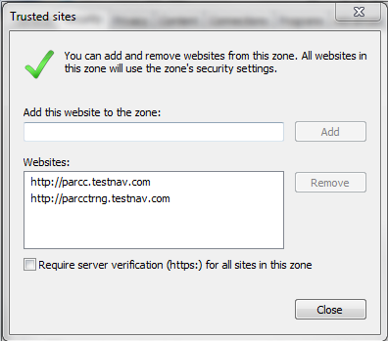

Pop-up Blocker

- You need to disable Pop-up Blocker per requirements from Pearson documentation:
- Uncheck the checkbox as shown below
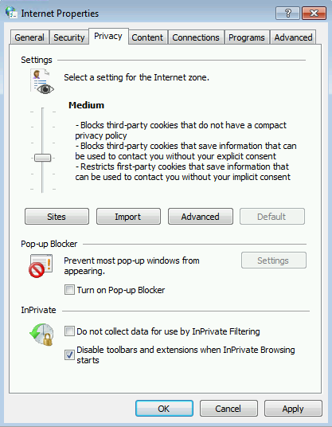

Java Certificates (Referenced from Dennis Hirschfelt)
- You need to add the Certificate from Pearson to stop the Run Application Prompt as shown below:
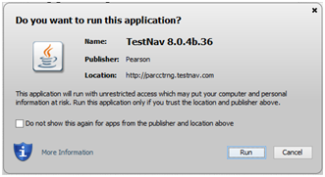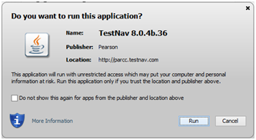

- You need to put a check in the box “Do not show this again for apps from the publisher and location above”, and click the Run button to accept the Certificate in the Java Trusted Certificate store as shown below.

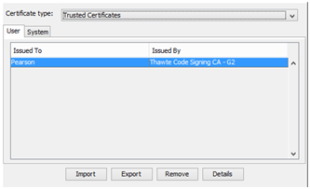

- Once the Certificate is stored there, you need to copy the Trusted.Certs file from this directory:

C:\Users\”username”\AppData\LocalLow\Sun\Java\Deployment\Security

Note: “username” is the user logged on the computer when you accepted the Certificate. The certificate is stored for the local user when it is accepted.

- You need to copy this file to the same directory for the users that will be logging into the machines to utilize TestNav.

