Proctor Caching Setup and Testing – Step 1

You can find the requirements for the Proctor Caching and TestNAV at this link: http://www.pearsononlinetesting.com/TestNav/8/index.html

You can download the Proctor Caching Server Installer for PC and MAC here:
http://www.pearsonaccess.com/cs/Satellite?c=Page&childpagename=PARCC%2FpcPALPLayout_v2&cid=1205795411747&p=1205795411747&pagename=pcPALPWrapper&resourcecategory=Technology+Information

Remember to set a static IP (recommended by Pearson) to the Proctor Caching machine. This IP should be internal to the districts network so that all of the testing machines can connect to it.

The Proctor Caching can be setup on anything from a workstation to a server. We recommend utilizing a server that is already in district (i.e. TEM Server Relay, old Lightspeed Server, or an unused application server).

To determine how many Proctor Caching machines you will need for the testing please setup the Proctor Caching and run the Testing Capacity test as shown below.

Find a wired machine (find a machine with a connection that meets the speed of the districts network, i.e. 1Gbps Network = 1Gbps workstation NIC to truly test the capacity of the Proctor Caching machine) that meets the TestNAV requirements. Utilizing the wired machine will allow you to find the number of Testing machines the Proctor Caching machine can run. If the "Testing Capacity Est." number is below the number of testing stations you will need to figure out the number of Proctor Caching machines to exceed that number.

Note: Please run the Testing Capacity test at the time the Field Tests will be given, and at least a week prior to the Infrastructure Trial.

Running SystemCheck (Refer to screenshot below)
The SystemCheck is found at this link: parcc.pearson.com/systemcheck
Click on the Start button. This will verify that the machine meets the requirements to check the Testing Capacity.
Click the tab "Testing Capacity". Add your Proctor Caching machine into the test by clicking the "Add Caching Computer" button (you can add more Proctor Caching machines by repeating that step). The port for the Proctor Caching is 4480. Click the "Start" button.

Note: If you have any Accomodations that require the Text to Speech test, be aware that you can test for this by changing the "Select test type:" drop down menu. The number will drop by roughly half, but this setting is for a school that is running mostly tests that require Accomodations for students.

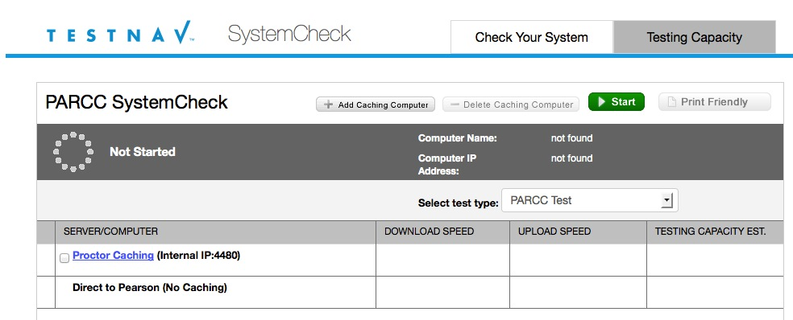

We are working on the Infrastructure Trial procedures – Step 2 and I will follow up with documentation and tips to help guide you through this process. Thank you for being a part of the Field Testing.

