Java 7 Update 55 Additional Prompt Prevention Directions

In collaboration with Edward Mlinarchik and the Dunkirk technical team we have identified the issue, and found a way to prevent this prompt from displaying on the screen during the TestNav login.

You will need to do the following on both websites parcctrng.testnav.com & parcc.testnav.com. Login in with the username of username and the password of password to execute the login without PearsonAccess credentials.

Note: Please reference the document “settings_to_disable_user_prompt_for_testnav.docx” on the wnyric.weebly.com website under the Technical link for other prompt prevention.

- When the prompt appears as shown below put a check in the box and click the Allow button
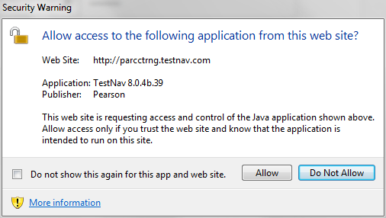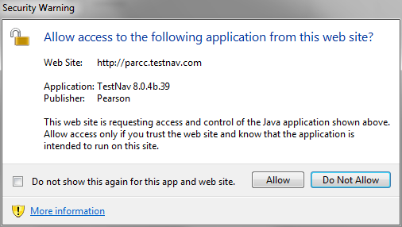
- After you have accomplished this task on both websites two files will be updated in the following locations with the files denoted below them (file names may vary):
C:\Users\”username”\AppData\LocalLow\Sun\Java\Deployment\cache\6.0\28
612c43dc-73857d9675c20d33221d18c887afb14d5ac9e239c946a3f1e1a9c428d6699209-6.0.lap
C:\Users\”username”\AppData\LocalLow\Sun\Java\Deployment\cache\6.0\29
54ab155d-44c8d1af70d0fd4604447dff0777fb761ea368dbb976a6f1c857a8e971f89149-6.0.lap

Note: “username” is the username logged on the computer when you allowed the application access.

- You need to copy these files to the same locations for the users that will be logging into the machines to utilize TestNav.

FYI… A codebase entry is created in each of the files that allows the TestNav application to run without prompting the user to accept. The entry for each file is as follows:

js.allowed.codebases=http//parcctrng.testnav.com\:80
js.allowed.codebases=http//parcc.testnav.com\:80

